**SQL Assignment 3**

1. **Create a function and then call another function from within it. What is this process called?**

* Creating a function and then calling another function from within it is referred to as nested function .

1. **What is the purpose of the MAXDOP and recompiling keywords in SQL queries?**

* MAXDOP: The purpose of using MAXDOP is to control the level of parallelism used by a specific query. By limiting the number of processors, you can fine-tune the query's impact on server resources and prevent excessive parallelism, which might lead to resource contention or performance issues.
* Recompiling: The purpose of using RECOMPILE is to ensure that a query always benefits from an optimal execution plan based on the current state of the database. By forcing the query to recompile and generate a new plan, you can adapt to changes in data distribution, statistics, or other factors that could affect the performance of the query.

1. **How to update data in a table using an inner join, write an example?**

* Assume you have two tables: "Customers" and "Orders." You want to update the email address of customers who have placed orders with a certain order status.

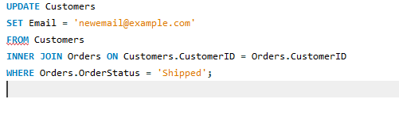

1. **Differentiate between truncate, delete, and drop with a suitable example.**

TRUNCATE: when you want to quickly remove all rows from a table without affecting the table structure. It's efficient but less flexible compared to DELETE.

Example:

TRUNCATE TABLE Orders;

DELETE: when you want to remove specific rows from a table based on certain conditions. It's more flexible but can be slower and is logged.

Example:

DELETE FROM Orders

WHERE OrderDate < DATEADD(YEAR, -1, GETDATE());

DROP : when you want to completely remove a database object (table, view, index). It's a more permanent action and cannot be undone.

Example:

DROP TABLE Orders;